Parallel Programing: Project A4

Drug Design and DNA using Parallel

1. The first step we did is compile the file to make an executable file for serial. (the screenshot will show that it was already made due to the first trial being successful.)

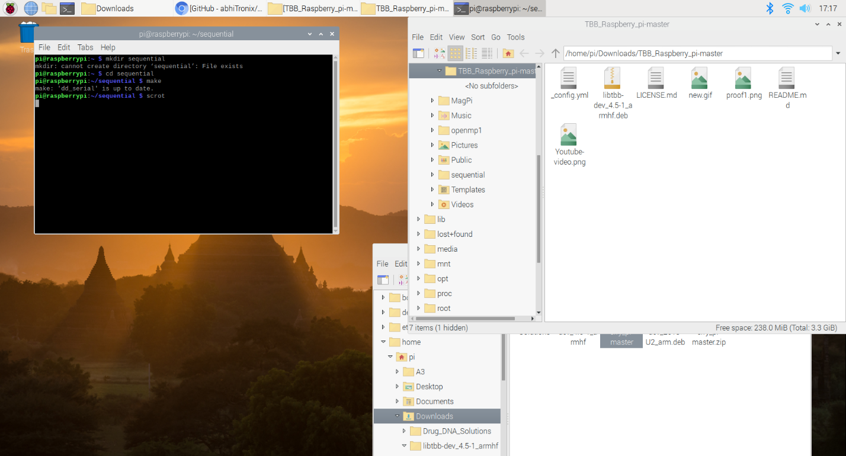

1. We ran the serial exe file and got our result “maximal score is 5, achieved by ligands, acech ieehkc.”

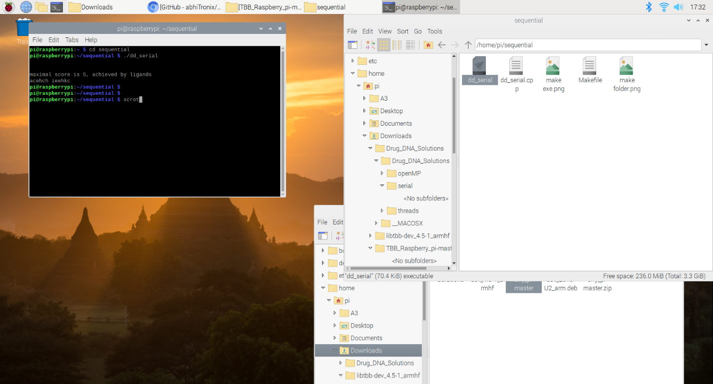

1. We had and issue with missing file for both the OpenMP code and also the C++ code. We were eventually able to find our solution by downloading and unpackaging the TBB file that was necessary to compile/run our program

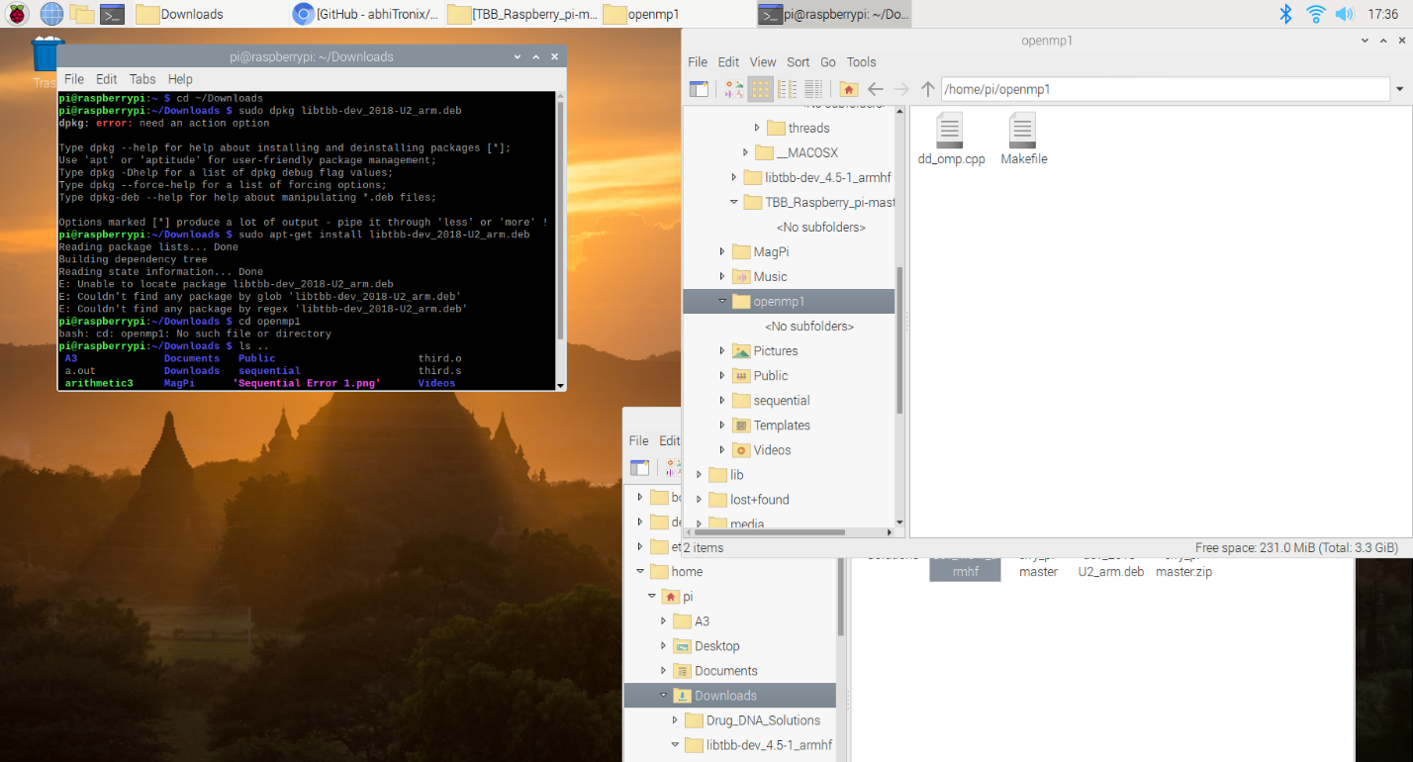

1. After unpackaging TBB, we were able to compile the OpenMp file.

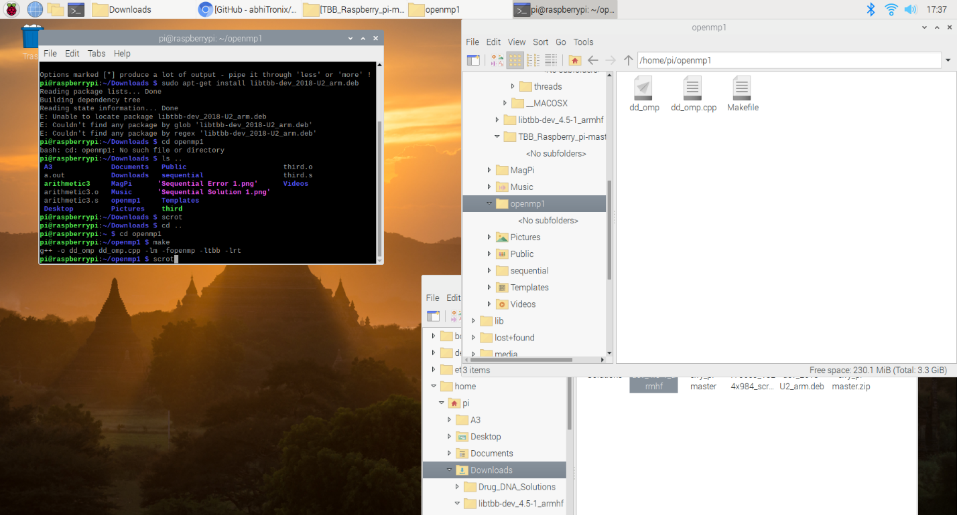

1. Here is the result of running the dd_omp file.

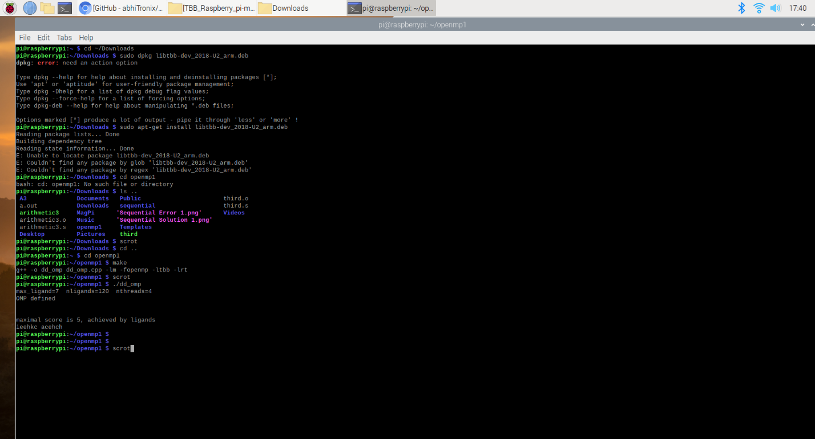

1. We then proceeded to compiling the C++ code into exe.

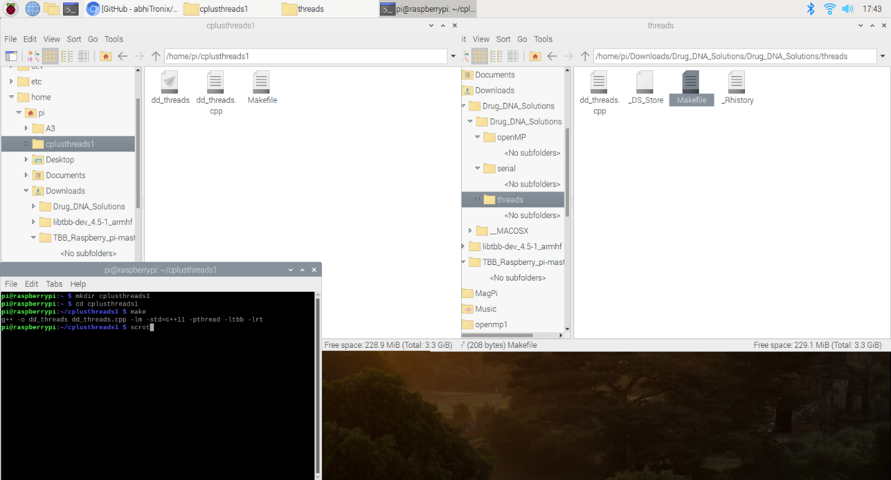

1. Here is the result of dd_threads.

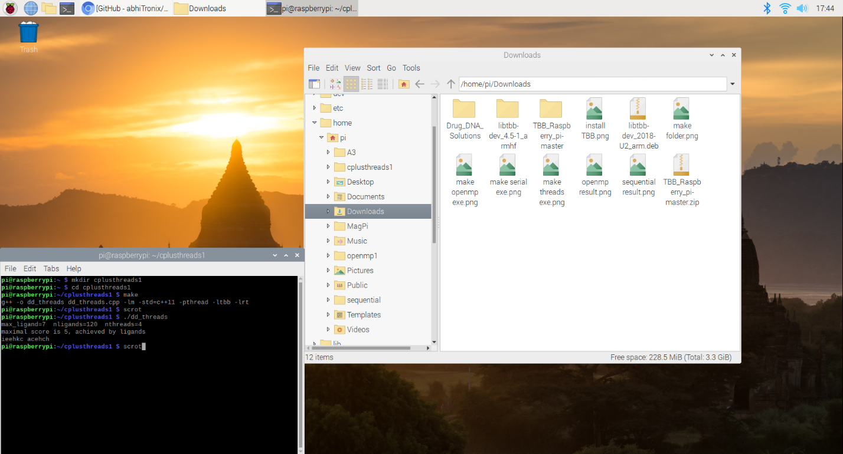

To measure the running time of each implementation, use time –p. For example (assuming you run make

already to create exe file for drugdesign-static):

time –p ./ dd_serial

time –p ./ dd_omp 1

time –p ./ dd_threads 1

Run and Fill out the table below (use real for time):

|  |  |
| --- | --- |
| Implementation | Time(s) |
| dd_serial | 143.27 |
| dd_omp | 0.02 |
| dd_threads | 0.02 |

Here are the screenshots for the results above:

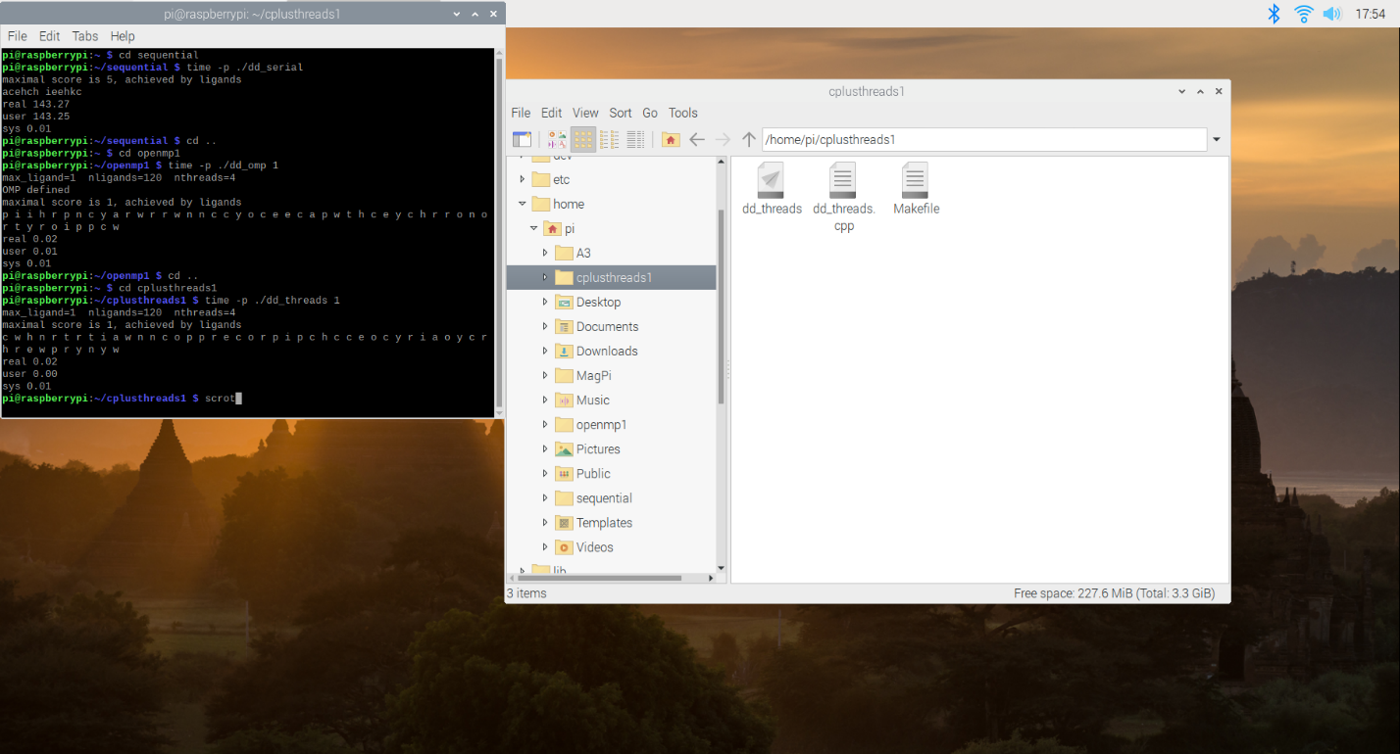

Run and Fill out the table below (use real for time):

time –p ./ dd_omp 2

time –p ./ dd_threads 2

time –p ./ dd_omp 3

time –p ./ dd_threads 3

time –p ./ dd_omp 4

time –p ./ dd_threads 4

|  |  |  |  |
| --- | --- | --- | --- |
| Implementation | Time(s) 2 Threads | Time(s) 3 Threads | Time(s) 4 Threads |
| dd_omp | 0.02 | 0.05 | 0.21 |
| dd_threads | 0.02 | 0.04 | 0.15 |

Here are the screenshots for the results above:

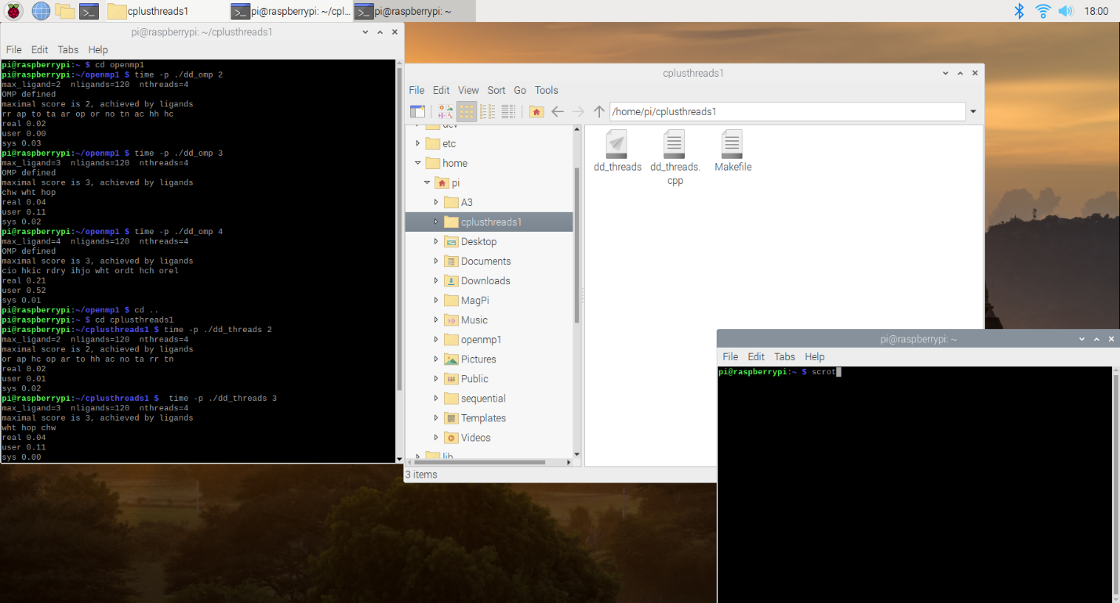

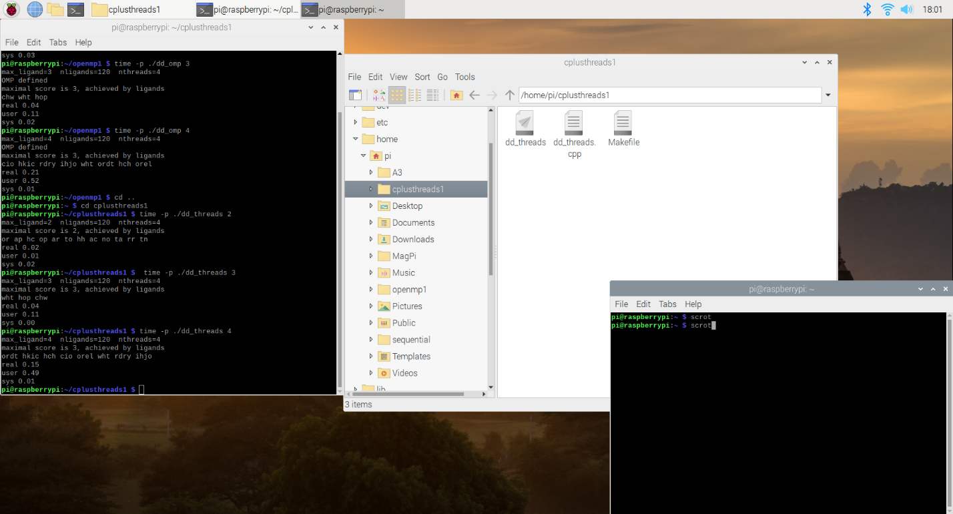

Discussion Questions

1. Which approach is the fastest?

Based on the results, using the threads (C++) is much faster than OpenMP and thus makes it the fastest.

1. Determine the number of lines in each file (use wc -l). How does the C++11

implementation compare to the OpenMP implementations?

The lines of C++ implementation of threads only have 140 lines in comparison to OpenMP’s 158

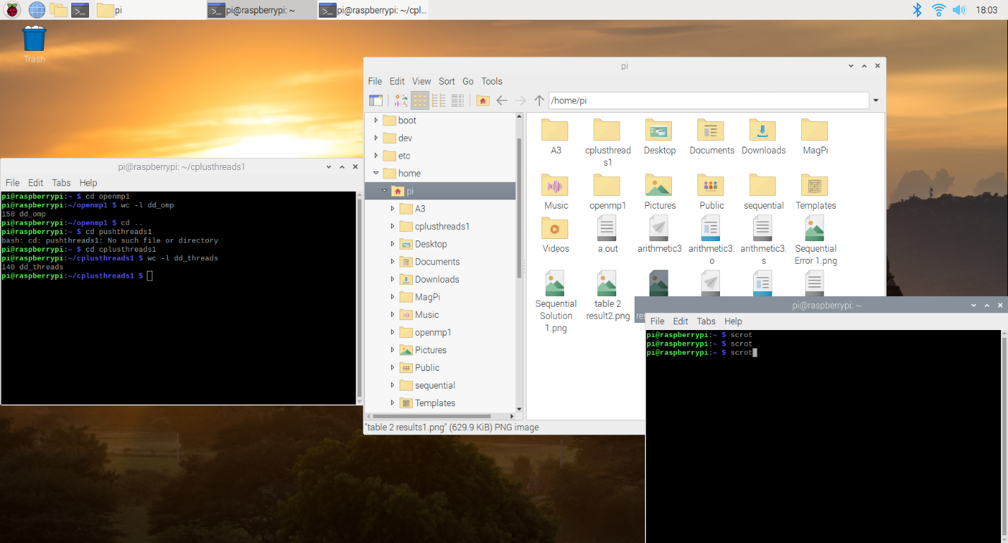

1. Increase the number of threads to 5 threads. What is the run time for each?

OpenMP: 1.1s

C++: 0.75s

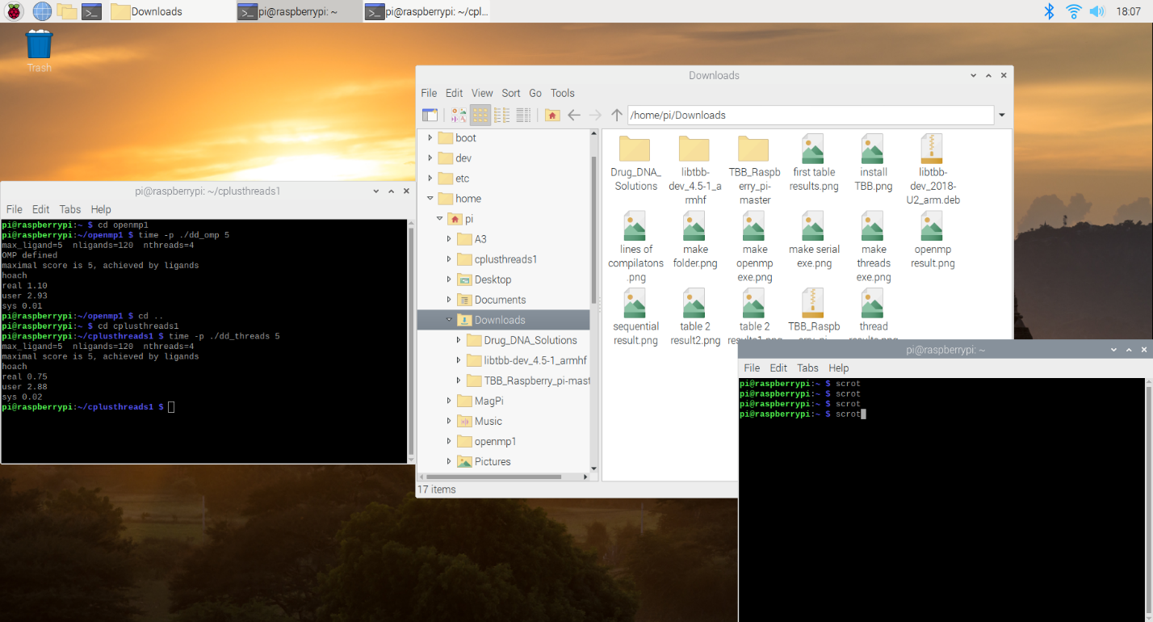

4. Increase the maximum ligand length to 7 and rerun each program. What is the run

time for each?

OpenMP: 80.72s

C++: 42.27s

